

**05**

**Diagram explanation ….**

* **User case diagram**
* **ER diagram**
* **Sequence diagram**
* **Class diagram**

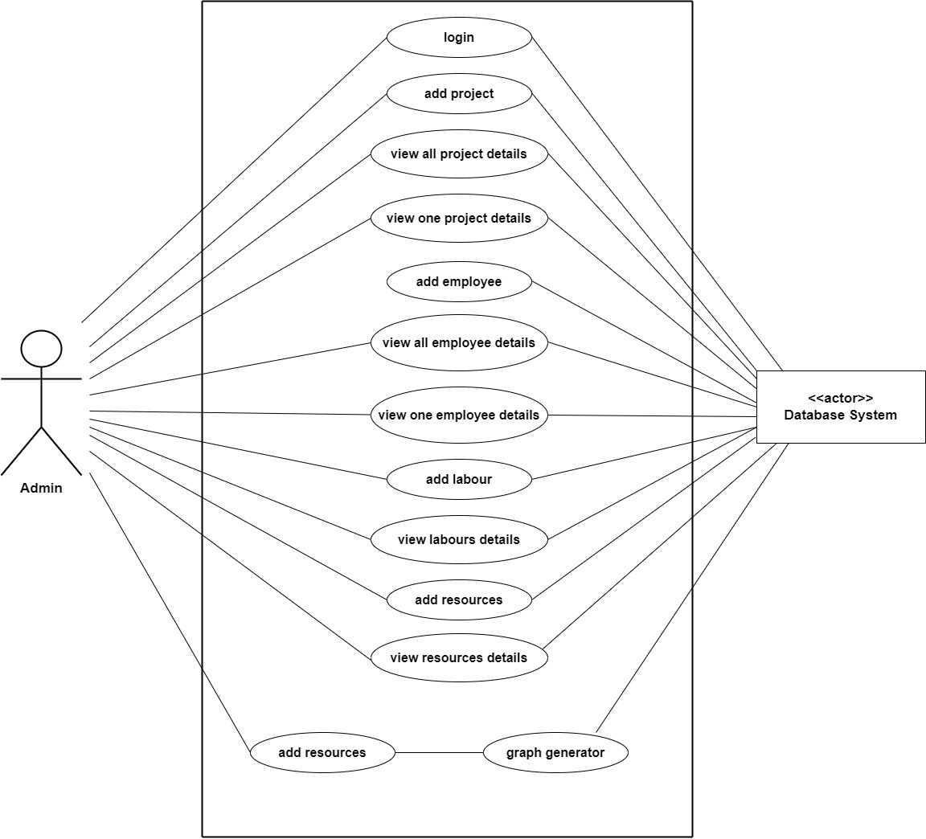**Use case diagram**

**ER diagram**

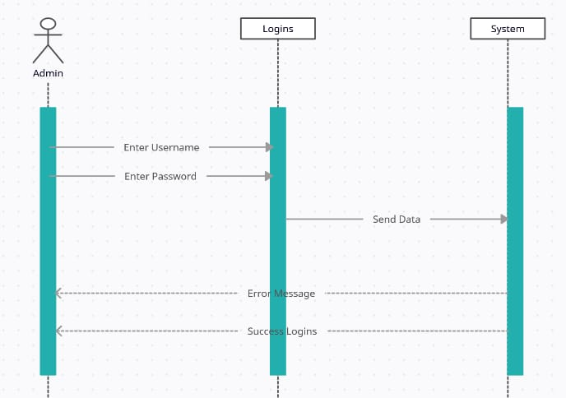**Sequence diagram**

**Class diagram**

